**Project** **Documentation**

**Store** **Manager – Keep Track of Inventory**

**1**. **Introduction**

- Project Title: Store Manager : keep track of inventory

- Team ID: [NM2025TMID40444]

- Team Leader: Dhanalakshmi.M [19052007dhanalakshmi@gmail.com]

**-** **Team** **Members**:

1 - Monisha.R – r.monishabubu1@gmail.com

2 - Keerthika.P– n.p.keerthika1627@gmail.com

3 - Kaviya.K –kkaviya7617@gmail.com

**2**.**project** **overview**

**Purpose**:

Store Manager is a front-end application designed to help users manage store inventory efficiently. It allows adding, editing, deleting, and viewing products in a clean and responsive interface.

- **Features**:

- Product listing and management

- Search and filter functionality

- Responsive design for desktop and mobile

- User-friendly UI for quick access to inventory data

**3**. **Architecture**

• Frontend: React.js with Bootstrap and tailwind CSS

• Backend: Node.js and Express.js managing server logic and API endpoints

• Database: MongoDB stores user data, project information, applications, and chat messages.

**4**. **Setup** **Instructions**

- Prerequisites:

- Node.js

- Git

- React.js

- Visual Studio Code

- **Installation** **Steps**:

`bash

#Clone the repository

git clone https://github.com/yourusername/store-manager.git

#Navigate to project folder

cd store-manager

#Install dependencies

npm install

#Start the development server

npm start

**5**. **Folder** **Structure**

`

store-manager/

├── public/

├── src/

│ ├── components/

│ ├── pages/

│ ├── assets/

│ ├── App.js

│ └── index.js

├── package.json

└── README.md

**6. Running the Application**

- Frontend:

`bash

cd store-manager

npm start

`

- Access:

Visit http://localhost:3000 in your browser

**7. API Documentation**

- /api/products – Get all products

- /api/products/:id – Get, update, or delete a specific product

- /api/products/create – Add a new product

**8**. **Authentication**

- JWT-based authentication

- Protected routes for admin access

**9. User Interface**

- Home Page

- Add Product Form

- Inventory Dashboard

- Product Catalog

- Search and Filter Panel

**10. Testing**

• Manual testing during milestones

• Tools: Postman, Chrome Dev Tools

**11. Screenshots or Demo**

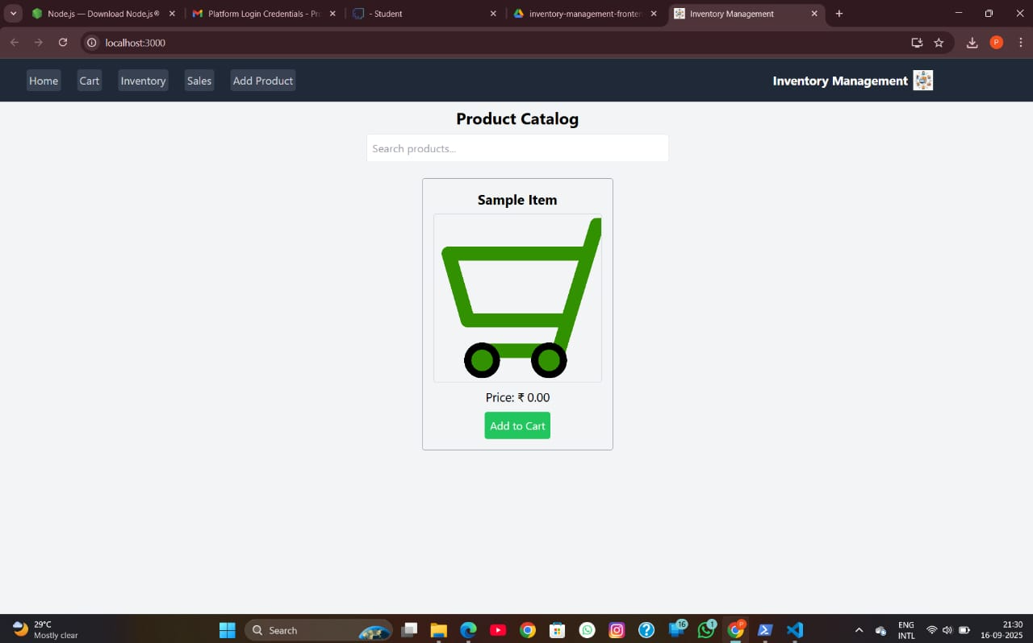

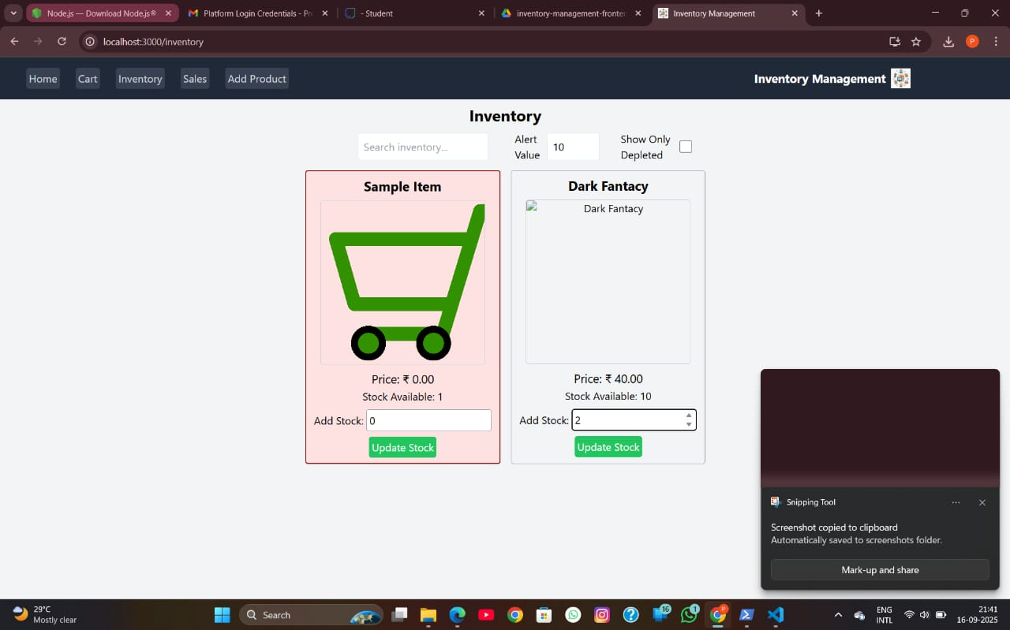

**12. Known Issues**

- No persistent storage without backend

- Limited to local state management

**13. Future Enhancements**

- Backend integration with Node.js and MongoDB

- User authentication and role-based access

- Export inventory reports

- Cloud deployment